Ideation Phase
Define the Problem Statements

Date | 31 January 2025
Team ID | LTVIP2026TMIDS91648
Project Name | Gemini Historical Artifact Description
Maximum Marks | 2 Marks

Customer Problem Statement Template:
Project: Gemini Historical Artifact Description
A well-defined customer problem statement helps us understand the real challenges faced by museum curators, history bloggers, researchers, and students while preparing historical artifact descriptions. By clearly identifying their difficulties, emotions, and needs, we can design an AI-powered solution that truly adds value and improves their experience.

Reference: https://miro.com/templates/customer-problem-statement/
Example:
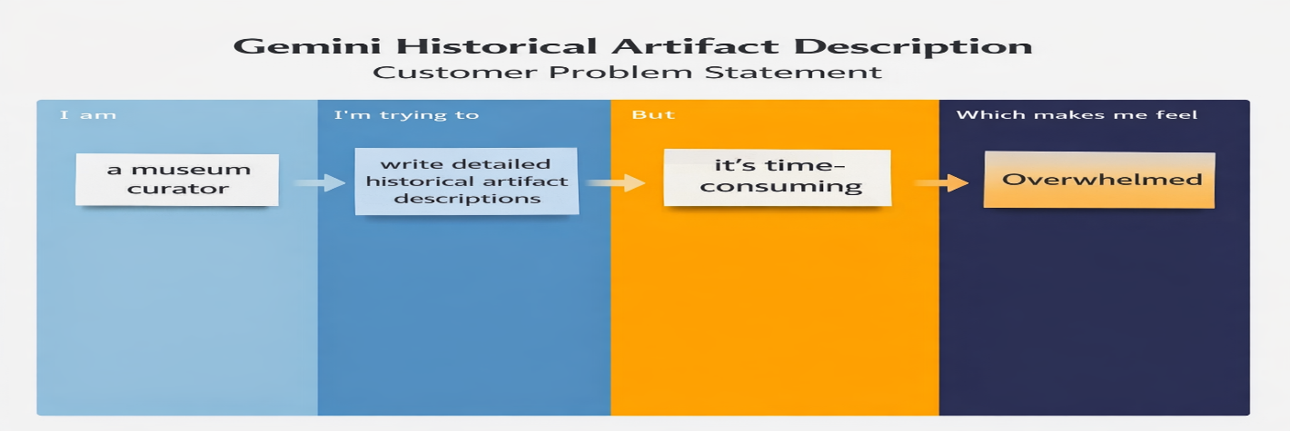

Problem Statement (PS) | I am (Customer) | I’m trying to | But | Because | Which makes me feel
PS-1 | I am a museum curator | I’m trying to create detailed and engaging artifact descriptions for exhibitions | But writing long, structured, and accurate content takes a lot of time | Because it requires research, proper formatting, and academic tone | Stressed and overwhelmed before exhibition deadlines
PS-2 | I am a history blogger | I’m trying to publish well-written artifact articles regularly | But organizing historical facts into professional long-form content is difficult | Because I struggle with structure and storytelling | Frustrated and unsure about my content quality
PS-3 | I am a history student | I’m trying to prepare assignment-ready artifact descriptions | But I don’t know how to structure the information properly | Because I lack experience in academic writing | Insecure and less confident about my submissions

